Lab 14 : Running Redpanda & Console Locally with rpk

Table of Contents
Table of Contents 2
Introduction 3
Learning Objectives 3
Prerequisites 3
Docker 3
Part 1 — Clean Environment 5
Part 2 — Start Redpanda Cluster 5
Verify Containers 6
Part 3 — Explore Redpanda Console 6
Verify Broker Health 7
Verify Overview Page 7
Part 4 — Validate Connectivity Using rpk 8
Create Topic 8
Produce Message 9
Consume Message 9
Part 5 — Inspect Logs for Troubleshooting 11
Part 6 — Understanding Local Workflow 12
Stop Cluster 12
Restart Cluster 12
Full Cleanup 12
Knowledge Check 13
Troubleshooting 13
Symptom: rpk container start fails with resource error 13
Symptom: Console not loading 13
Symptom: Broker unhealthy 14
Conclusion 14

Introduction
In this lab, you will deploy Redpanda locally using rpk container, which automatically:
- Starts Redpanda broker
- Configures networking
- Launches Redpanda Console
- Sets up required Docker network
- Creates a ready-to-use local streaming environment
Unlike Docker Compose, rpk container abstracts configuration complexity and provides a streamlined development experience.

Learning Objectives
By the end of this lab, you will:
- Start Redpanda using rpk container
- Access and navigate Redpanda Console
- Verify broker health and metadata
- Create and inspect topics
- Produce and consume messages
- Inspect container logs
- Understand local container lifecycle using rpk

Prerequisites
Ensure the following are installed:

Docker
docker --version
rpk Installed
Verify:
rpk version
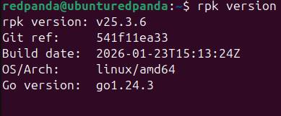
Verify again:
rpk version

Part 1 — Clean Environment
Always start clean:
rpk container purge
What this does:
- Stops all rpk-managed containers
- Removes Docker network
- Removes volumes
Concept:
This ensures no stale cluster configuration remains.

Part 2 — Start Redpanda Cluster
Start single-node cluster:
rpk container start
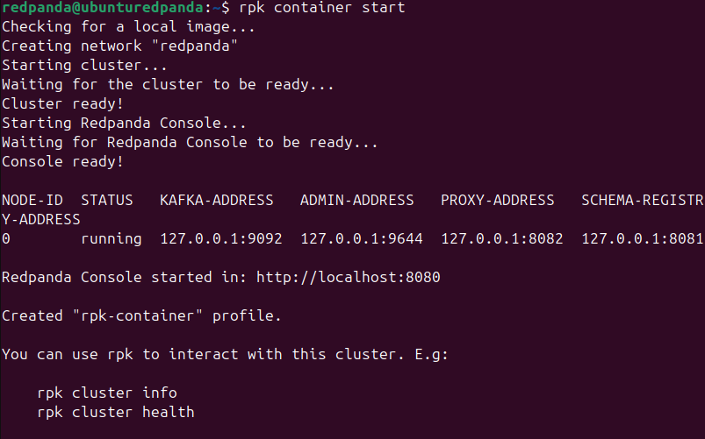
Expected Output:
You will see:
- Node 0
- Kafka address: 127.0.0.1:9092
- Admin address: 127.0.0.1:9644
- Console started at: http://localhost:8080
Important:
rpk container start automatically launches Console.

Verify Containers
docker ps
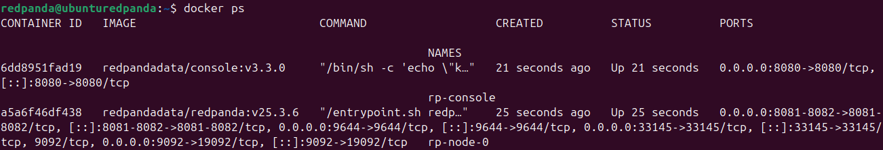
You should see:
- redpanda
- redpanda-console

Part 3 — Explore Redpanda Console
Open browser:
http://localhost:8080

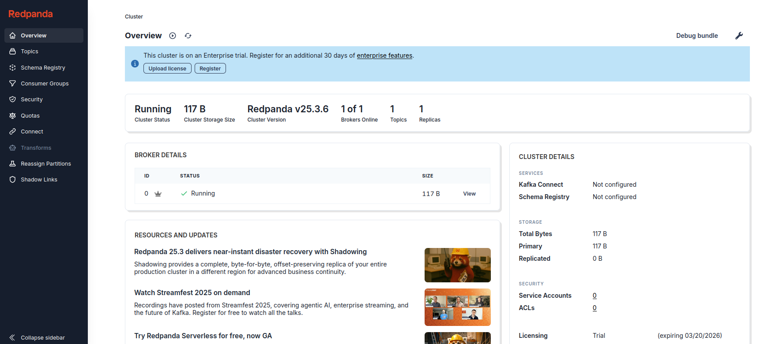

Verify Broker Health
Click:
Cluster → Brokers
You should see:
- Node 0
- Status: Healthy

Verify Overview Page
You should see:
- 1 Broker Online
- Cluster Healthy
- 0 Topics

Part 4 — Validate Connectivity Using rpk
Check cluster info:
rpk cluster info
Expected:
- Cluster ID
- Node 0
- Status healthy
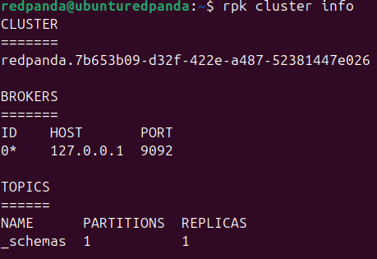
Short Concept:
This queries Admin API (9644) directly.

Create Topic
rpk topic create test-topic
Verify:
rpk topic list
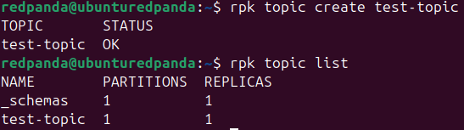
Now refresh Console → Topics
You should see test-topic.

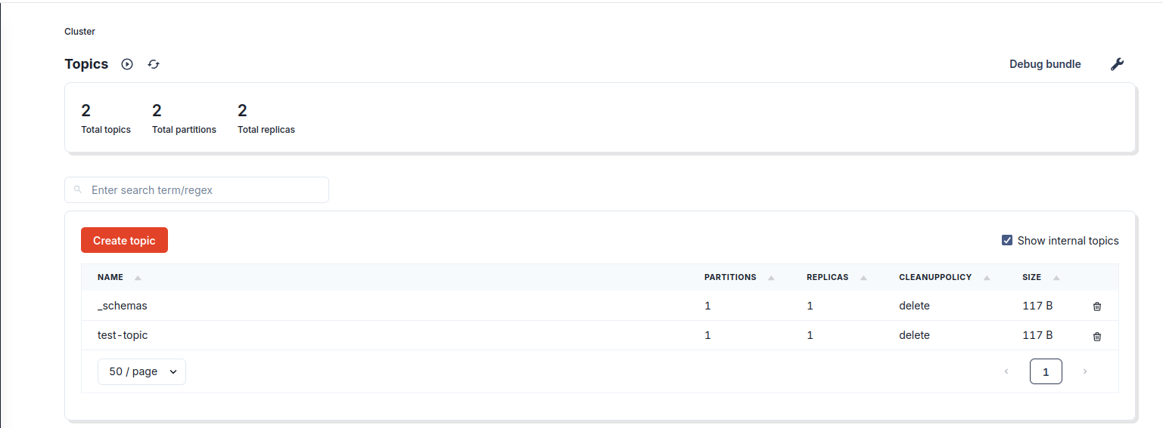

Produce Message
rpk topic produce test-topic
Type:
Hello from rpk
Press Ctrl+D.

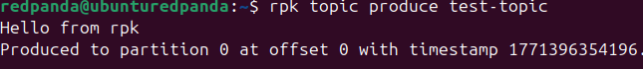

Consume Message
rpk topic consume test-topic
Press Ctrl + C
You will see:
- Topic
- Partition
- Offset
- Value
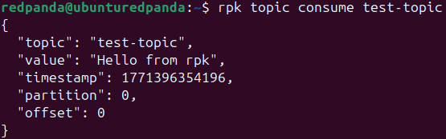
Concept:
Offset = sequential index of message inside partition.

Part 5 — Inspect Logs for Troubleshooting
Find container names:
docker ps
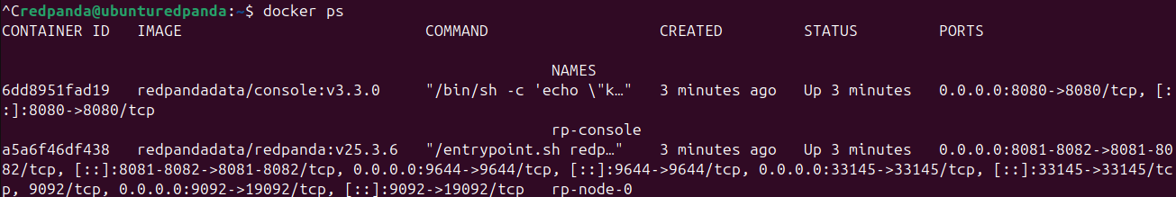
View broker logs:
docker logs rp-node-0
View console logs:
docker logs rp-console
What to look for:
- ERROR
- Failed connections
- Port binding issues

Part 6 — Understanding Local Workflow

Stop Cluster
rpk container stop
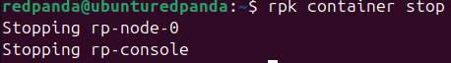
Check:
docker ps
Containers will be stopped.

Restart Cluster
rpk container start

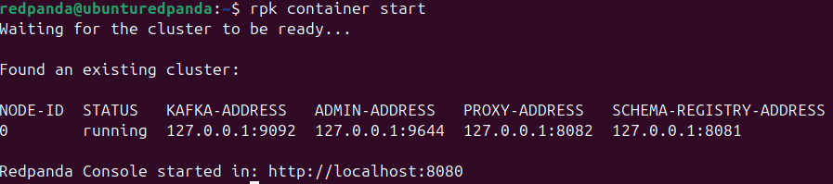

Full Cleanup
rpk container purge
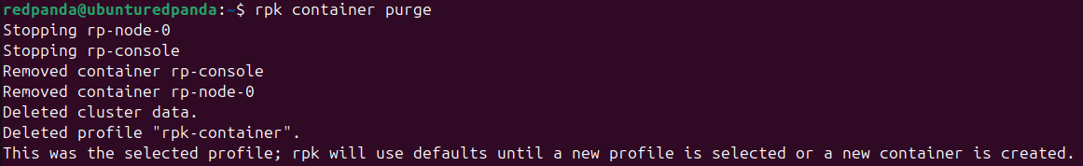
Removes:
- Containers
- Network
- Data
Concept:
This simulates ephemeral development clusters.

Knowledge Check
- What command starts a Redpanda container cluster?
- What URL is used to access Console by default?
- What does rpk container purge do?
- Which port does Kafka use by default?
- What does an offset represent?

Troubleshooting

Symptom: rpk container start fails with resource error
Fix (Linux only):
sudo sysctl -w fs.aio-max-nr=1048576
Then:
rpk container purge
rpk container start

Symptom: Console not loading
Check:
rpk cluster info
docker ps
docker logs redpanda-console

Symptom: Broker unhealthy
Check:
docker logs redpanda
Common causes:
- Insufficient memory
- Port conflict
- AIO limit

Conclusion
In this lab, you:
- Deployed Redpanda using rpk container
- Accessed Console
- Created topics
- Produced and consumed messages
- Inspected logs
- Managed container lifecycle
You now understand:
- How Redpanda runs locally
- How Console connects to brokers
- How to validate cluster health
- How to manage development clusters using rpk
This forms the operational foundation for building production-grade streaming systems.

